**Industrial Interaction Report on**



**BUSINESS GROWTH INTERN**



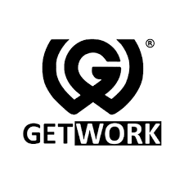

**GETWORK**

**Submitted in partial fulfilment of the requirement for the award of the degree of**

**BACHELOR OF TECHNOLOGY**

**IN**

**COMPUTER SCIENCE & ENGINEERIN(ARTIFICIAL INTELLIGENCE & MACHINE LEARNING)**

**Submitted by:**

**Shristy Chaudhary** **2019498**



**Department of Computer Science and Engineering**

**Graphic Era (Deemed to be University)**

**Dehradun, Uttarakhand**

**2024-25**



**CANDIDATE’S DECLARATION**

I hereby certify that the work which is being presented in the Industrial Interaction report entitled **“BUSINESS GROWTH INTERN”** in partial fulfillment of the requirements for the award of the Degree of Bachelor of Technology in Artificial Intelligence and Machine Learning in the Department of Computer Science and Engineering of the Graphic Era (Deemed to be University), Dehradun shall be carried out by the undersigned under the supervision of **MR. JITENDER SAINI**, Department of UNIVERSITY RELATIONS & PARTNERSHIPS, Getwork.

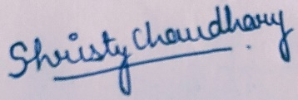

SHRISTY CHAUDHARY

2019498

AI & ML

**CERTIFICATE**

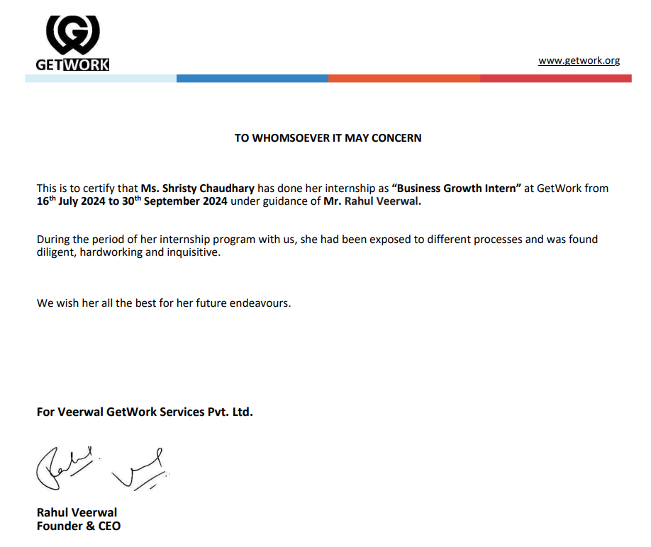

**CONTACT DETAILS**

During my internship at **GETWORK**, I had the opportunity to work closely with several professionals who guided and supported my learning and tasks. Below are the contact details of the relevant persons who were involved in my internship experience:

1. **Manager**

* **Name –** Jitender Saini
* **Position –** Manager-University Relations & Partnerships
* **Email –** jitendersainich@gmail.com
* **LinkedIn -** https://www.linkedin.com/in/jitendersaini25/

1. **HR Manager**

* **Name –** Yashika Rohilla
* **Position –** Senior Executive - HR
* **Email –** yashika@getwork.org
* **LinkedIn -** https://www.linkedin.com/in/yashika-rohilla-1029b41aa/

1. **Founder and CEO**

* **Name –** Rahul Veerwal
* **Position –** Founder & CEO
* **Email –** rahul@getwork.org
* **LinkedIn -** https://www.linkedin.com/in/rahulveerwal/

**Table of Contents**

|  |  |  |
| --- | --- | --- |
| **Chapter No.** | **Description** | **Page No.** |
| Chapter 1 | About the Company | 7 - 9 |
| Chapter 2 | Work Responsibilities | 10 |
| Chapter 3 | Work Details | 11 – 12 |
| Chapter 4 | Skills Learned | 13 - 14 |
| Chapter 5 | Conclusion | 15 |
|  |  |  |

**ACKNOWLEDGEMENT**

I am sincerely grateful to **Getwork Private Limited** for the invaluable opportunity to intern with them, allowing me to learn and grow under their esteemed guidance. This internship, held from **16 July , 2024, to Sep 30, 2024**, was a pivotal experience that contributed significantly to my academic and professional development.

I extend my heartfelt thanks to **Jitender Saini**, Manager (University Relations and Partnerships), whose insightful guidance and constructive feedback were instrumental in my successful completion of this program.

I would also like to acknowledge the support and encouragement from the entire Getwork team, whose collaborative spirit made my internship experience both productive and enjoyable. Additionally, my sincere gratitude goes to my faculty at **Graphic Era Deemed to be University**, and to my family and friends, whose unwavering support and guidance facilitated this internship experience.

Thank you all for making this internship a memorable and enriching milestone in my academic journey.

**CHAPTER - 1**

**ABOUT THE COMPANY**

GetWork is a prominent platform that bridges the gap between students, colleges, and corporate offices by providing tailored job opportunities and enhancing employability. Founded with the vision to streamline the hiring process, GetWork collaborates with educational institutions and organizations to create a robust ecosystem where students can access a plethora of job listings, internships, and skill development resources. Colleges benefit from the platform's ability to track student progress and placement statistics, while companies can efficiently connect with a pool of talented and pre-vetted candidates. This integrated approach ensures that all stakeholders can effectively meet their recruitment and career development goals.

The company offers a user-friendly interface that simplifies the registration process for students, enabling them to create comprehensive profiles, apply for jobs, and receive updates on relevant openings. Colleges are provided with tools to manage and monitor the placement activities of their students, ensuring that they can offer the best opportunities to their graduates. Corporate offices can leverage GetWork's extensive database to find suitable candidates who meet their specific requirements, thereby reducing the time and effort spent on recruitment. Overall, GetWork aims to revolutionize the employment landscape by fostering connections that lead to meaningful career advancements.

* 1. **Mission**

The mission of GetWork is to streamline the recruitment process by connecting students, colleges, and corporate offices through a unified platform. It aims to enhance employability by providing students with access to job opportunities, internships, and skill development resources while enabling colleges to manage placement activities efficiently and helping companies find the right talent swiftly.

* 1. **Vision**

The vision of GetWork is to create a seamless ecosystem where students, educational institutions, and corporate entities are interconnected, fostering a world where every student finds the right career path and every company discovers the ideal candidate effortlessly. By leveraging technology and innovative solutions, GetWork aspires to transform the employment landscape, making it more efficient, transparent, and accessible for all stakeholders.

* 1. **Key Features and Strengths**

Getworks’s offerings are designed to support continuous learning and providing job opportunities through:

* **Comprehensive Job Matching:** GetWork offers an extensive database of job listings and internships, ensuring students find opportunities that align with their skills and career goals. The platform's advanced matching algorithms connect candidates with roles that best suit their profiles, enhancing job placement success rates.
* **Integrated College and Corporate Tools**: The platform provides educational institutions with tools to manage and monitor placement activities, track student progress, and maintain placement statistics. For corporate offices, GetWork streamlines the recruitment process by offering access to a pool of pre-vetted and talented candidates, saving time and resources.
* **User Friendly Interface**: With an intuitive and easy-to-navigate interface, GetWork simplifies the registration and job application processes for students. This ensures that users can quickly create profiles, apply for jobs, and stay updated on relevant opportunities with minimal hassle.
* **Skill Development Resources**: GetWork is committed to enhancing student employability by offering a variety of skill development resources, such as workshops, training sessions, and webinars. These resources help students build the necessary skills to succeed in their chosen careers and stand out to potential employers.
  1. **Leadership Team**

Getwork’s success is driven by a passionate team committed to transforming education through technology:

* **Rahul Veerwal, Founder & CEO**: Rahul Veerwal, the CEO of GetWork, is a visionary leader dedicated to transforming the employment landscape by leveraging technology and innovative solutions. With a deep understanding of the challenges faced by students, colleges, and corporate offices, he has spearheaded the development of a platform that seamlessly connects these stakeholders, ensuring that each can achieve their goals efficiently. Under his leadership, GetWork has become a pivotal tool in bridging the gap between education and employment, providing students with the resources and opportunities they need to succeed in their careers.

Their commitment to transformation extends beyond mere job placements. He advocates for continuous skill development and lifelong learning, recognizing the rapidly changing demands of the modern workforce. By integrating workshops, training sessions, and other educational resources into the GetWork platform, he ensures that students are not only prepared for their first job but are also equipped for long-term career growth. His efforts are making a significant impact on how students and employers approach recruitment, ultimately contributing to a more dynamic and efficient job market.

The dedicated efforts of their team and the broader Getwork community contribute to an organization that is dynamic, forward-thinking, and committed to delivering exceptional learning experiences to students worldwide.

**CHAPTER – 2**

**WORK RESPONSIBILITIES**

This internship was a 12 weeks Business Growth internship. During this period, the

following tasks have been successfully performed:

* **Market Research and Analysis:** Conduct detailed market research to identify trends, opportunities, and competitive landscape within the employment sector. Utilize AI and ML tools to analyze large datasets, providing actionable insights to inform business strategies.
* **Lead Generation and Outreach**: Develop and implement strategies for lead generation using AI-powered CRM tools. Engage with potential clients through targeted outreach campaigns, leveraging ML algorithms to personalize communication and improve conversion rates.
* **Data-Driven Decision Making**: Assist in the collection, processing, and analysis of data to support decision-making processes. Use ML models to predict market trends, customer behavior, and other key metrics that drive business growth.
* **Product Development Support**: Collaborate with the product development team to integrate AI and ML features into the GetWork platform. Provide insights and recommendations based on user data and feedback to enhance platform functionality and user experience.
* **Performance Metrics and Reporting**: Track and analyze key performance indicators (KPIs) related to business growth initiatives. Utilize AI analytics tools to generate detailed reports, identifying areas of success and opportunities for improvement.
* **Content Creation and Optimization**: Create engaging content for marketing and outreach campaigns, incorporating AI tools to optimize for search engines and user engagement. Use ML algorithms to tailor content to specific audience segments, improving relevance and impact.

**CHAPTER – 3**

**WORK DETAILS**

As a Business Growth Intern with a focus on AI & ML at GetWork, I have been involved in a variety of tasks aimed at driving the company's growth and enhancing its platform capabilities. The internship had encompass the following responsibilities:

1. **Market Research and Analysis:**
   * Conduct in-depth research to identify market trends, customer needs, and competitive strategies.
   * Utilize AI and ML tools to analyze market data and generate insights that support strategic planning.
   * Prepare reports and presentations to share your findings with the team.
2. **Lead Generation and Outreach:**
   * Develop and execute lead generation strategies using AI-powered CRM systems.
   * Identify potential clients and partners through data-driven approaches.
   * Conduct outreach campaigns, leveraging ML algorithms to personalize messages and improve engagement.
3. **Data Collection and Analysis:**
   * Gather and process data from various sources, including user interactions, market trends, and internal metrics.
   * Apply ML models to predict customer behavior, market trends, and other key performance indicators.
   * Assist in creating dashboards and visualizations to present data insights clearly.
4. **Support Product Development:**
   * Work closely with the product development team to integrate AI and ML features into the GetWork platform.
   * Analyze user feedback and data to provide recommendations for product enhancements.
   * Participate in brainstorming sessions and contribute ideas for new features and improvements.
5. **Performance Tracking and Reporting:**
   * Monitor and track the performance of business growth initiatives using AI analytics tools.
   * Generate detailed reports on key metrics, such as user acquisition, engagement, and retention.
   * Identify areas of success and opportunities for optimization based on data analysis.
6. **Content Creation and Optimization:**
   * Create and optimize content for marketing campaigns, including blog posts, social media updates, and email newsletters.
   * Use AI tools to ensure content is SEO-friendly and tailored to specific audience segments.
   * Measure the effectiveness of content campaigns and adjust strategies based on performance data.

Throughout the internship, I have gain hands-on experience with AI and ML technologies, enhance your analytical and strategic thinking skills, and contribute to real-world business growth projects. I had also have the opportunity to work in a collaborative environment, learn from experienced professionals, and make a meaningful impact on GetWork's mission to connect students, colleges, and corporate offices.

**CHAPTER – 4**

**SKILLS LEARNED**

This internship helped me in learning various technical skills as well as also improve my

communication and interpersonal skills.

Some of the skills that I was able to learn/improvise are:

**Data Analysis and Interpretation**:

* Mastery of data collection, cleaning, and processing techniques.
* Proficiency in using AI and ML tools for analyzing large datasets.
* Ability to generate actionable insights and create detailed reports based on data analysis.

**AI and ML Applications**:

* Practical experience in implementing AI and ML algorithms for business applications.
* Understanding of how to use machine learning models to predict trends and customer behavior.
* Hands-on experience with AI-powered CRM systems and analytics tools.

**Market Research and Competitive Analysis**:

* Skills in conducting thorough market research and identifying key industry trends.
* Ability to analyze the competitive landscape and formulate strategic recommendations.
* Experience in preparing comprehensive market analysis reports.

**Lead Generation and Customer Outreach**:

* Expertise in developing and executing lead generation strategies.
* Proficiency in using AI tools to personalize outreach and improve engagement.
* Skills in managing and nurturing client relationships.

**Content Creation and Digital Marketing**:

* Ability to create engaging and optimized content for various digital marketing channels.
* Knowledge of SEO best practices and experience with AI tools for content optimization.
* Skills in measuring the effectiveness of content and adjusting strategies accordingly.

**Product Development and User Experience**:

* Experience in collaborating with product development teams to enhance platform features.
* Skills in gathering and analyzing user feedback to inform product improvements.
* Understanding of user experience design principles and their application in product development.

**Performance Metrics and Business Reporting**:

* Proficiency in tracking and analyzing key performance indicators (KPIs).
* Skills in creating detailed performance reports and dashboards.
* Ability to identify areas for improvement and optimize business growth strategies.

**Project Management and Collaboration**:

* Experience in managing multiple tasks and projects effectively.
* Skills in working collaboratively with cross-functional teams.
* Ability to contribute ideas and solutions in a team environment.

By the end of the internship, I have developed a well-rounded skill set that combines technical proficiency in AI and ML with strategic business acumen, making you well-prepared for future career opportunities in the field of business growth and technology. Apart from this I was also able to gain knowledge about behavioural skills.

**CHAPTER -5**

**CONCLUSION**

In conclusion, my internship at GetWork has been an immensely rewarding and transformative experience. Throughout the internship, I had the opportunity to delve into various aspects of business growth, with a particular focus on the application of AI and ML technologies. The skills I have acquired in data analysis, market research, lead generation, content creation, and product development have equipped me with a comprehensive understanding of the strategies and tools necessary to drive business success.

The hands-on experience with AI-powered CRM systems, machine learning models, and digital marketing strategies has significantly enhanced my technical proficiency and analytical capabilities. Additionally, collaborating with cross-functional teams and contributing to real-world projects has honed my project management and teamwork skills. This internship has not only expanded my knowledge and expertise but also reinforced my passion for leveraging technology to create impactful business solutions.

Overall, my time at GetWork has prepared me for future challenges and opportunities in the dynamic field of business growth and technology. I am grateful for the guidance and support provided by the GetWork team, and I am confident that the skills and experiences gained during this internship will serve as a strong foundation for my professional career.